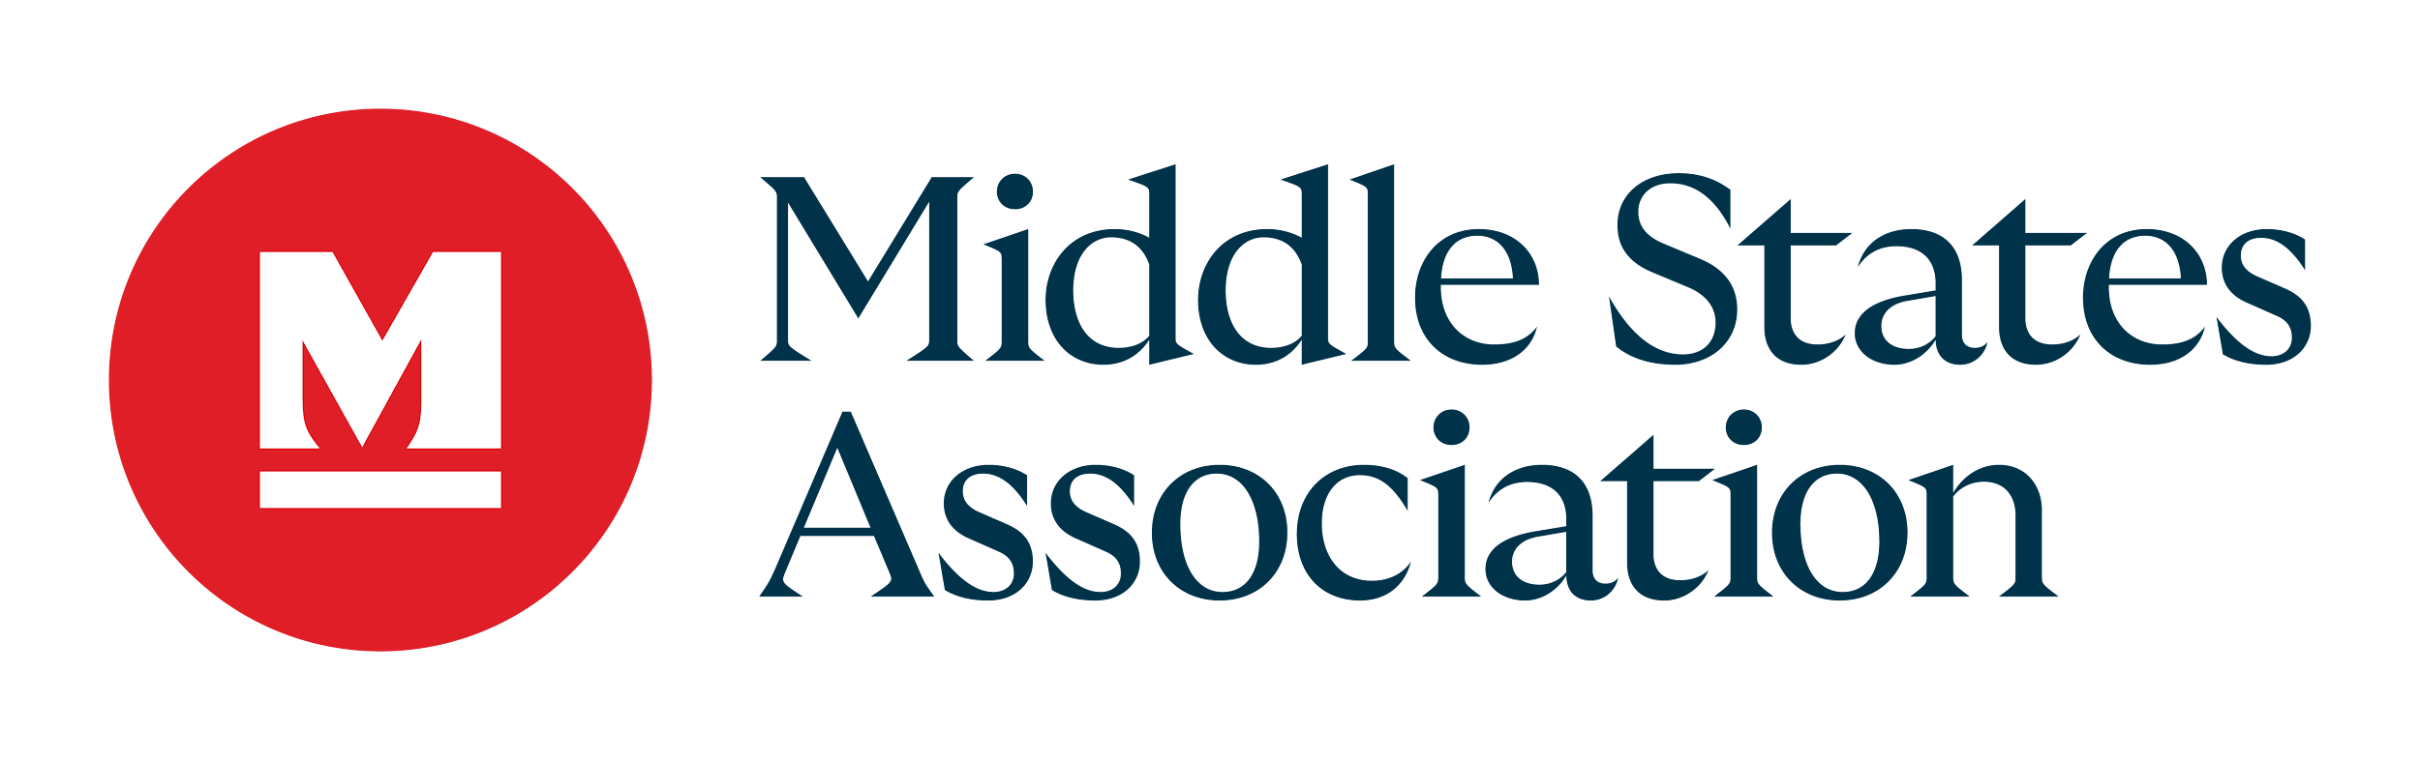
MSA REPRESENTATIVE VISITOR STANDARDS REPORT

NAME OF SCHOOL:
COOPERATING ACCREDITATION AGENCY:
VISIT DATES:
MSA REPRESENTATIVE:

Please complete the report indicating your assessment of the school’s adherence to each of the 5 MSA Standards. In order for our Staff, Advisory Committee, and Commissions to make a valid assessment, we ask you to make comments for each Standard and include positive feedback as well as recommendations.

Please reference your training materials for full definitions, but below are definitions for any corrective actions the visiting team/Cooperative Agency may be asking the school to complete:
Recommendation – Any area in which the visiting team has made suggestions for improving an area in the school or its operations

Monitoring Issue – Any corrective action that is required but the school has already began or has included in the Continuous School Improvement Plan.

Stipulation – Any corrective action that is a glaring omission in the school’s operations or in the meeting of the Standard/Indicators and is NOT found in the Continuous School Improvement Plan.

Should you feel that the school does not meet a Standard, please provide a reason and reference the Standard Indicator(s).

If you should have any questions or concerns, please reach out to the Cooperative Agency Liaison – Daniel Rufo at drufo@msa-cess.org

Once you have completed the report please submit it to reports@msa-cess.org

FOUNDATIONS STANDARD FOR ACCREDITATION

Observations, Comments, Recommendations, Monitoring Issues, OR Stipulations:

The MSA Representative’s assessment is that the school meets the Standard

The MSA Representative’s assessment is that the school does not meet the Standard for the reason(s) stated below.
REASON:

GOVERNANCE AND ORGANIZATION STANDARD FOR ACCREDITATION

Observations, Comments, Recommendations, Monitoring Issues, OR Stipulations:

The MSA Representative’s assessment is that the school meets the Standard

The MSA Representative’s assessment is that the school does not meet the Standard for the reason(s) stated below.
REASON:

STUDENT WELL-BEING STANDARD FOR ACCREDITATION

Observations, Comments, Recommendations, Monitoring Issues, OR Stipulations:

The MSA Representative’s assessment is that the school meets the Standard

The MSA Representative’s assessment is that the school does not meet the Standard for the reason(s) stated below.
REASON:

RESOURCES STANDARD FOR ACCREDITATION

Observations, Comments, Recommendations, Monitoring Issues, OR Stipulations:

The MSA Representative’s assessment is that the school meets the Standard

The MSA Representative’s assessment is that the school does not meet the Standard for the reason(s) stated below.
REASON:

TEACHING AND LEARNING STANDARD FOR ACCREDITATION

Observations, Comments, Recommendations, Monitoring Issues, OR Stipulations:

The MSA Representative’s assessment is that the school meets the Standard

The MSA Representative’s assessment is that the school does not meet the Standard for the reason(s) stated below.
REASON:

Do you feel the school's compliance with the requirements of the cooperative's protocol serve as an equivalency for MSA requirements for accreditation?
If not what additional information should the school be required to submit?

Special Purpose Indicator(s):

Overall Comments:

SIGNATURE OF MSA REPRESENTATIVE DATE

Thank you for your service to Middle States Association Commissions on Elementary and Secondary Schools and their partner associations.

